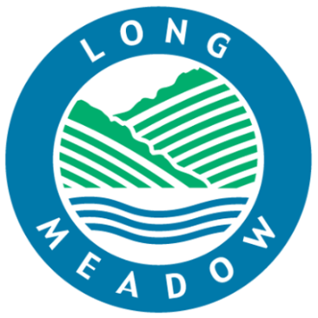
LONG MEADOW SCHOOL
Garthwaite Crescent, Shenley Brook End, Milton Keynes, MK5 7XX
(01908 508678 – fax: 01908 520630)
e-mail: office@longmeadow.milton-keynes.sch.uk
web: www.longmeadow.milton-keynes.sch.uk

Headteacher: Mr Philip Gray BEd (Hons) CANTAB, NPQH

Wednesday 23rd September

Dear Parents / Carers,

I wanted to write to you to share a few things today. I hope this letter finds everyone as well as can be expected in the current circumstances and if you, or any of your family, are currently unwell, we really do wish you a speedy recovery.

Firstly, a huge thank you to those parents who have contacted or spoken to us to say they appreciate our efforts in these challenging times. It really has been lovely to hear that people understand that we are all trying our very best for our whole school community at the moment. I genuinely feel proud to work alongside such a committed, flexible, hardworking and supportive staff and I want to publicly thank them for all that they are doing at the moment, whether in school or isolating at home.

Please find attached an updated flowchart from Milton Keynes Council regarding what to do if your child displays any COVID 19 symptoms. Public Health shared with me today what they define as close contact and I believe it is important to share with you too: close contact is defined as being within two metres for fifteen minutes or more OR within one metre for one minute or more.

May I remind you that if you have a child at home who is isolating this means they have to stay at home until their return to school date. As detailed in the bubble closure letters I sent out last week, this is to reduce the further spread of COVID 19 to others in the community. We have been made aware that some children who should be isolating have been seen out and about around Milton Keynes. National guidelines state that, “from 28 September, you could be fined if the guidance around staying at home and self-isolate is not followed.”

After technical issues with Google Classroom, we are now able to use this for our virtual learning provision from Monday 28th September. Early Years will continue to use Tapestry alongside Google Classroom. We will continue to provide learning to be completed at home for those children whose bubbles are closed, or for children who are isolating at home due to family members isolating. As emailed earlier in the week, we will not be providing learning for children whose bubble is open but their parents have decided to keep them at home. If you have any issues regarding this, we have created a new email for you to contact: GoogleClassrooomIssues@longmeadow.miton-keynes.sch.uk For example, if a child has forgotten their password you can use this email address to contact us and we will endeavour to rectify the issue as soon as possible.
Many thanks for your support at the moment and always. As ever, we remain #proud of our entire school community through these unprecedented times.

Yours sincerely

Emma Kidd
Deputy Head Teacher

