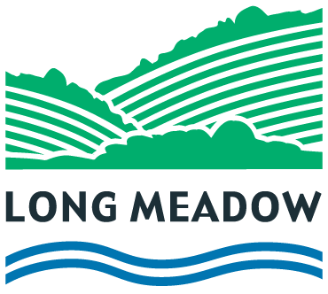

GENERAL DATA PROTECTION REGULATION

The Data Protection Officer for Long Meadow School is:

Mrs Beverley Midwood

beverleydpservices@gmail.com

